About What Rookies not good at trial and error need to know.

Sections Order and relationship of this file's segments.
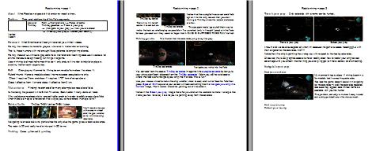 | Foreword Refit → Trial-and-error → Fields of battle  TinAlley TinAlley gazelles → There is your prey  → (Navigate to your prey) → Now you are closer
→ (Heat up your prey → Collect your bounty)
Veritas
Vulcan

Foreword What Sinstrite and Waervyn never tell you in their videos.

Frankly, the videos are made for players who revel in trial-and-error learning.

That is, those humans with not enough life experience to temper impatience.

Frankly, those of us with extra grey cells hate trial-and-error learning because it wastes a lot of time that could be sprnt doing fun things in a game.

Ascent mining is almost hell-on-earth to do - I only endure it in order to help later players avoid my hell-on-earth experience.

Refit Changing my Mammoth's Mining beam module from class 1 to class 11.

Rule-of-thumb: Higher a module's class, the more space occupied on a ship.

Class 1 requires 2 tons and class 11 requires 1,707 tons of cargo s[ace.

Class 1 effective from 1 km and class 11 effective from 2 km.

Trial-and-error Finding the orchard after many attempts to cross a lava field.

Its like being the peasant in the British TV series, Back Addler – many dents on head.

Why would anyone choose to try one path after another in order to safely cross a lava field when there is a map to a hovercraft that will get you to the orchard in an eye blink?

Fields of battle TinAlley THEN Veritas THEN Vulcan,
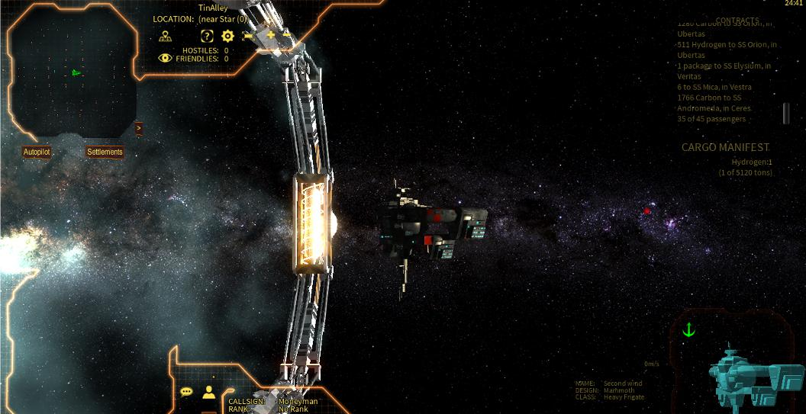 | 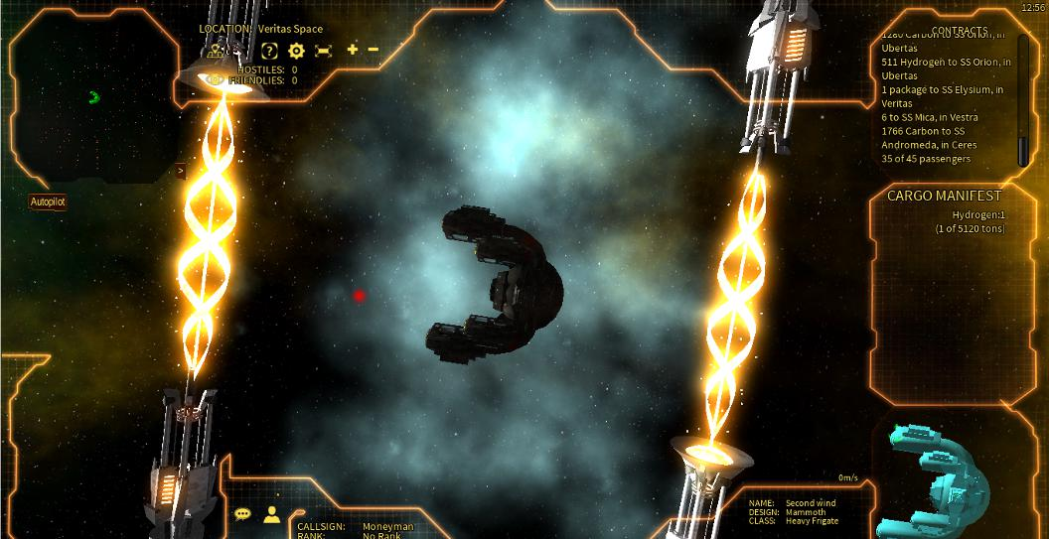 | 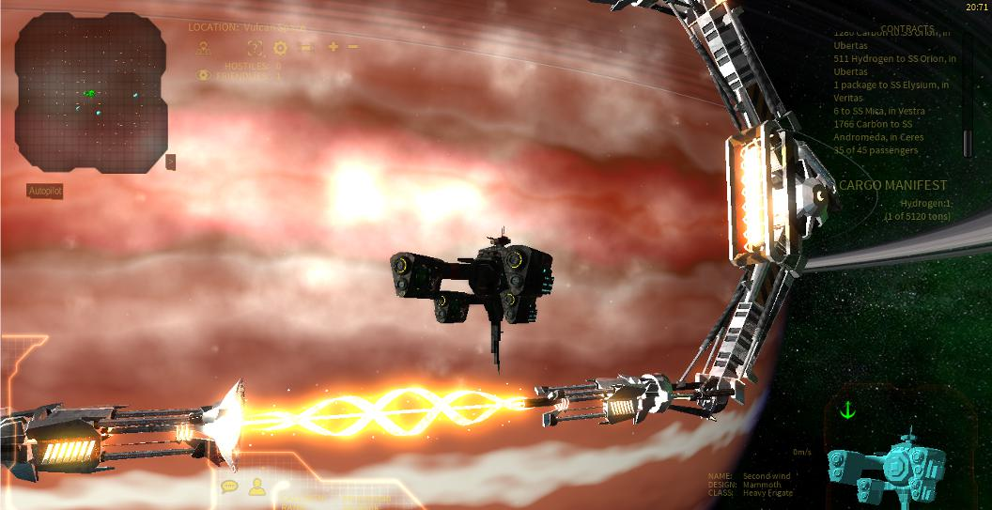 | You'll need a mouse with a zoom wheel and the grav anchor on to minimize ship rotations.
Navigating to an asteroid is no picnic since the only clue the game gives is relative distance.

The radar is 2D and really hard to interpret in 3D terms.

TinAlley Ceres → Menzel 3 → inAlley
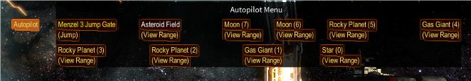  TinAlley autopilot  There it is: In the left corner – reset button. | 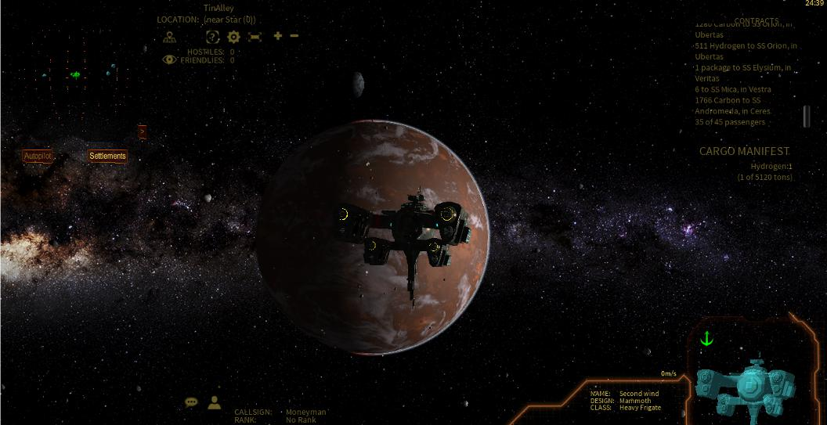  TinAlley asteroids | Notice that the autopilot has an asteroid field option – its the only reason that you start mining at TinAlley since the asteroid choices are few.  The programmer(s) go out-of-their-way to
make the task as challenging as possible – I've punched (only in thought) people in the face for less provocation – they seem to forget that A GAME IS SUPPOSED TO BE FUN! Not hell.

TinAlley gazelles The illusion that the asteroids jump away like prey.
TinAlley asteroids | 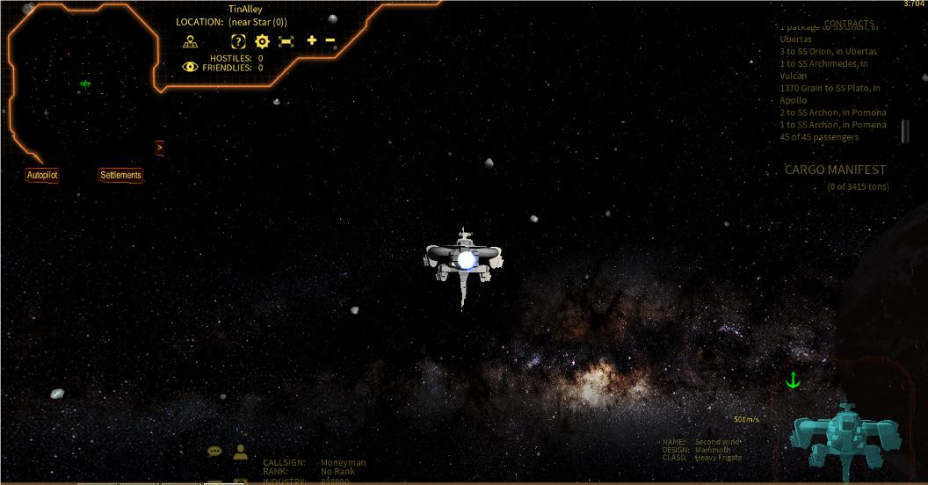  Navigate your ship into the field

You can see from the above TinAlley asteroids image that the autopilot asteroid button puts your ship a significant distance from the TinAlley asteroids field – you still have to locate where the field is and navigate your ship into the field. This is fun?

Use your mouse wheel to make the ship smaller (more to see) and turn to face the field then press Space + Shift keys and your screen will look something like the Navigate your ship into the field image,.The thrusters should be pointing out of the screen.

Notice in the Select your prey image that after you click on the asteroid to make it a target that it tells you how far away it is and your is pointing away from the asteroid.

There is your prey Only asteroids with a name can be hunted.
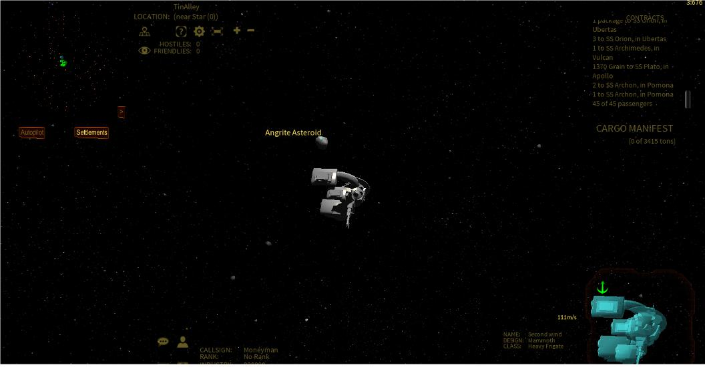  There is your prey | 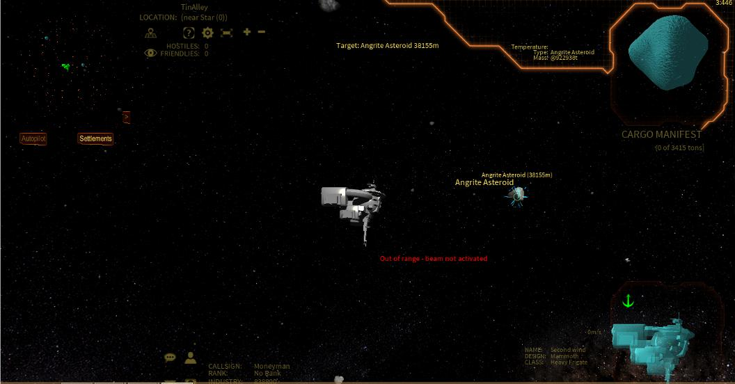  Select your prey

I mouth a lot words of exasperation when I'm because the game is soooo heeelllpppful with the navigation to the asteroids. NOT!!!

Notice how the ship is pointing the wrong way with respect to the nearby asteroids.

Of course, this is 2D graphics soooo its never realllly clear how to vector your ship to best advantage until you smash into the thing you are trying get to – have done a lot of smashing.

Navigate to your prey

Now you are closer
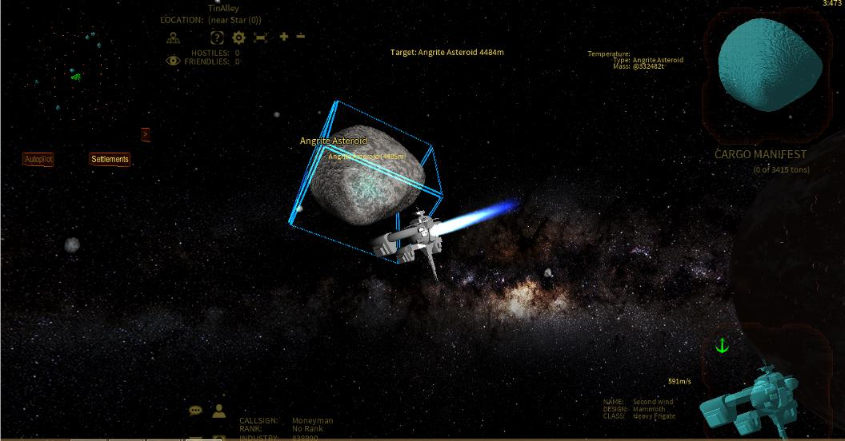 | My mammoth has a class 11 mining beam – s formidable tool in smashing asteroids.  Too bad the game doesn't assist in navigating to the asteroids – I call the asteroids gazelles because they appear determined not to be sociable with you the hunter.  The problem, actually. is makes it easy to add extra ship pertubations – thanks so much.

Heat up your prey
Collect your bounty

