About What Rookies not good at trial and error need to know.

Content Foreword → After docking → Earlier → Two ships in the Hanger
→ Selling the Sparrow → Did it work?

Foreword This file guides first in its images THEN the explanation of the action(s).

One of the reasons why the moment-to-moment game player population is, on average, so small – only players good at trial-an-error learning thrive in this game environment and that is tiny compared to the potential (Ex: Battlestar Galactica) game population.

I've only succeeded because I knock down challenges AND the game's generous players.

File images obtained during Hornet and Sparrow ship sale offers.

After docking View: Vestra starbase screen → Starbase actions → Starting Sell window

I docked my Falcon at Vestra → Clicked Place Sell Order → Sell menu appeared
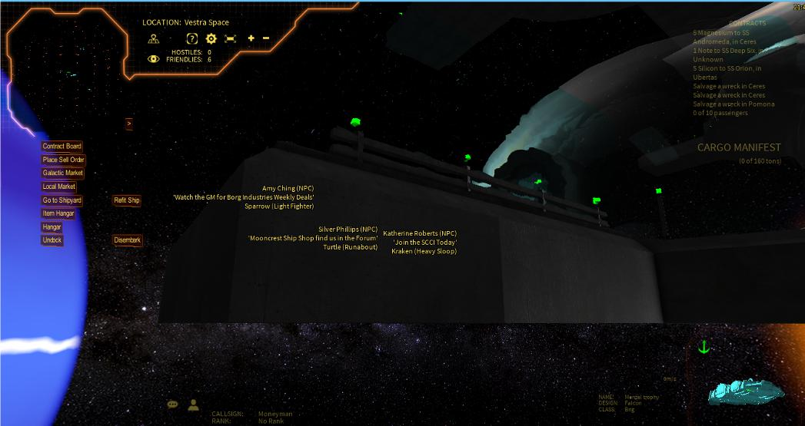  Vestra starbase screen | 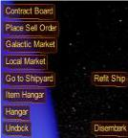  Starbase actions
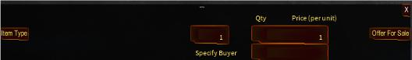
Starting Sell window
At any location that has a Galactic Market, there is also a Place Sell Order menu button.

The station's Item Hangar holds resources and ship modules.

You can only sell a ship in in the station's Hangar – the ship you arrived in is not available for sale unless you disembark (See above Starbase actions image) the ship.

The usual reason to offer a ship for sale is its your current ship and you want to replace for a more expensive ship obtainable at the same starbase – in that case you must use the disembark button shown in the Starbase actions image to make the sell offer..
Earlier I bought a Sparrow then Unicorn then Manta and finally a Falcon.

In my case, I am goimg to starbases where I left lower capacity ships and bought the next expensive ship for Menzel 3 ↔ Ceres Carbon buy / sells.

At the time, I didn't know how to sell the current ship (i. e. Why disembark was important.) before getting the next ship or how to ask another player how to make the sell offer.

I also didn;t know about the external Wiki and my Steam video guides weren't working.

Waervyn's Galactic Market Video – Selling requires some thought (Atleast, for me) to understand that he is talking about selling his current ship and, unless the player can get another ship, the player is spending the rest of game eternity at that starbase.

I needed to know that another ship was handy before I'd willing to sell my current ship.

That is why ship buying and delayed ship selling looked like the safest game strategy.

Two ships in the Hanger View: Starbase actions → Sell with item dropdown

I clicked Item Type → Below window with item dropdown appeared → Clicked Ship
Starbase actions | 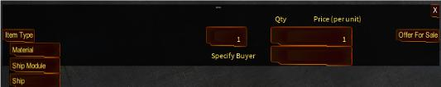  Sell with item dropdown
 | A generous player told me about the Ascent forum which led me to the Ascent Wiki. Finally, armed with a guide (Steam guides were broken) that I could use, I was ready to sell my Hornet.
I parked my Falcon at Vestra where I had, much earlier in game playing, switched my Hornet for a Sparrow – That switch was just before my Menzel 3 ↔ Ceres Carbon buy / sells.

Once again, I needed a generous player's help to discover a mistake that the Wiki and the video overlooked – the Ascent program expects only numbers not commas or letters.

Why doesn't the Sell price box tell you that?

The menu system is very similar to the Galactic Market interface (Will be used to verify that the offer is listed) with an Item Type menu button – So I needed to click Ship from the above dropdown menu.

When you choose an Item Type, click the Select button and a list of items you own in that category will become available.

If you've disembarked your only ship at the starbase – only your current ship is listed.

Selling the Sparrow View: Select ship → Ship select dropdown → Sparrow sell price
→ Sell listing cost → Next available item

I needed a lot of help completing the Hornet sale.

In order not to waste the player's (who was helping me) time, I stopped taking Hornet sale screenshots – I resumed the screenshots with Sparrow (different starbase) ship sale.

Click Select → Click Sparrow → Key 22500 → Click Offer to Sell → Click Yes
→ A switch to Item Hanger (farming robots) occurs.
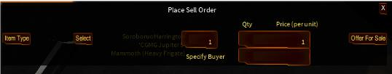  Select ship | 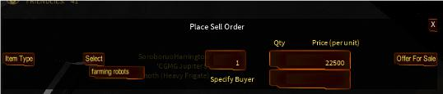  Next available item
  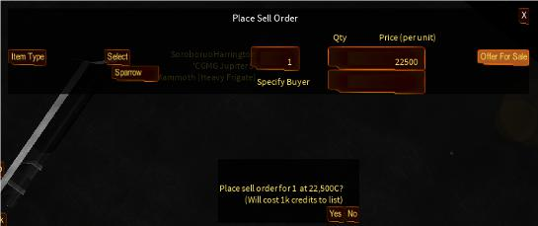
  Sell listing cost
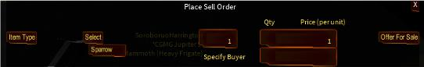
Ship select dropdown
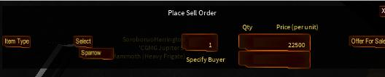
Sparrow sell price
After Ship was selected from Item Type then the contents of the Hangar (Except the Falcon) at the Vestra station is displayed as a dropdown menu.

To sell on the open market, leave the Specify Buyer area empty.

I sold the Hornet to the player assisting me in completing my first ship sale by keying the player's game name into the (lower) Specify Buyer box.

When you click the Offer to Sell button, a confirmation box will appear. Clicking Yes will initiate the transaction.

The order is placed on the market and 1,000 credits are deducted as an expense.

The common game action is a green confirmation line, however, for this transaction the game detected farming robots and switched to the Item Hanger – anticipating that the player might want to make an Item Hanger offer.

In selling my Unicorn, at another starbase, I got a green confirmation line.

Did it work? View: Starbase actions → Check by ship price → Confirm as my sale

You can always buy back your order. Since there is no cancellation feature, jJust use the Galactic Market, find your order, and purchase your order back.

So a quick guide on the basics of the Galactic Market is now coming ...

Click Galactic Market → Select Item Type Ship → Key Sparrow → Click Search
→ Dropdown menu with Sparrow offering prices → Click 22500 Sparrow offering price
Starbase actions | 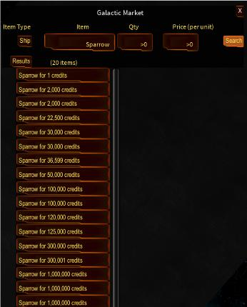  Check by ship price | 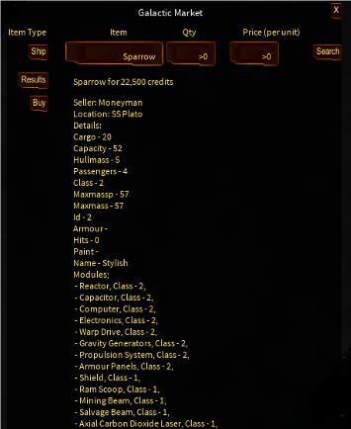  Confirm as my sale
Note that a $22.5k offer is not necessarily your offer – clicking on the listed offer is really something you need to do.

I recommend, after any changes you require, that this file be a download click in the Wiki's Place Sell Order web page.

