About Using uniform 3D objects, a & b, to explain axial distance and motion ideas.
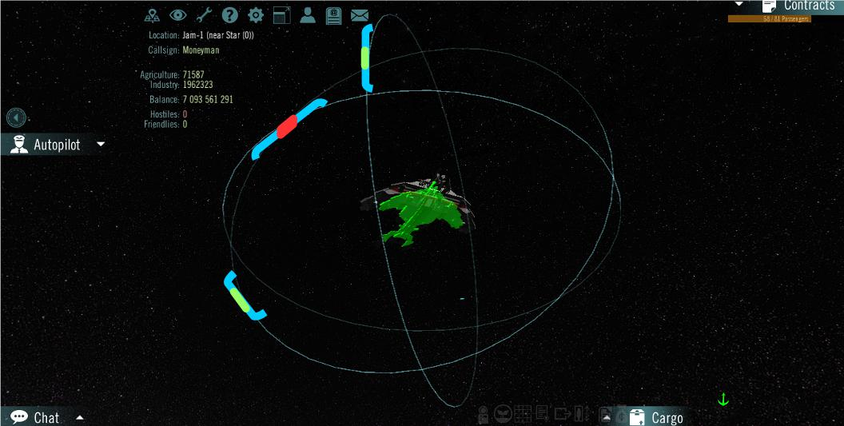 | A blue color strip is axial distance.  A green color strip means axial distance is getting smaller.  A red color strip means axial distance is getting bigger.  A color strip is easier to understand and react to than a number since humans are innately image orientated while numbers require a image to concept mental calculation.

Content Axial stationary distance → Relax restriction → Object b in motion
→ Both objects in motion → Benefit to players → Benefit to JAM

Axial stationary distance Moment-to-moment intervening space between 3D objects.

In uniform objects, this is the intervening space between object center-of-gravity axis vector points less uniform axis origin extents.

For an given moment: a's center-of-gravity axis vector is (x1,y1,z1) and
b's center-of-gravity axis vector is (x2,y2,z2).

Let a's grid axial range be: (-a1:a1,-a2:a2,-a3:a3) relative to (x1,y1,z1) and
b's grid axial range be: (-b1:b1,-b2:b2,-b3:b3) relative to (x2,y2,z2).

For a the axis origin extents are: a1, a2 and a3.
For b the axis origin extents are: b1, b2 and b3.

Assume a comes-before b or (x1<x2,y1<y2,z1<z2) and a and b are both stationary.

Then collision point range is: (x1 + a1:x2 - b1,y1 + a2:y2 - b2,z1 + a3:z2 – b3)

Assume, initially, no grid overlap in the above range vector ex: x1 + a1 < x2 - b1.

Stationary distance vector = (x2 – b1 - x1 + a1, y2 – b2 - y1 + a2, z2 – b3 - z1 + a3).

X axis collision if |x2 – b1| = (x1 + a1) – i. e. nothing between a's and b's x axis borders.

Relax restriction Position of a and b arbitrary except no object overlap.

The stationary distance vector requires absolute value calculations – ex: |x2 – b1| > -1

Stationary distance vector under relaxed restriction:

(||x2 – b1| - |x1 + a1||, ||y2 – b2| - |y1 + a2||, ||z2 – b3| -| z1 + a3||)

Object b in motion Current b's motion vector = (bx, by, bz).
If a given axis motion < 0 then use green and motion >0 then use red in radar image.

Recalculate (x2,y2,z2) as (x2+bx, y2+by, z2+bz) then calculate distance vector using the above stationary distance vector formula.

Both objects in motion Current a's vector = (ax, ay, az) and b's vector = (bx, by, bz).
For motion: Use green when motion >0
and use red when motion <0.

Recalculate (x1, y1, z1) as (x1 + ax, y1 + ay, z1 + az)
and (x2, y2, z2) as (x2 + bx, y2 + by, z2 + bz)

Calculate distance vector using the above stationary distance vector formula.

Benefit to players Now players see when the player's ship overshoots a target because the blue distance measure starts getting bigger in one or more axis(s).

If the rate of change in any axis changes from green to red – the target approach is becoming an overshoot in that axis – the game becomes fun, again,

Benefit to JAM NASA may be calling.

The only remaining issue is how to match a's and b's motion – something for you to add at another time – especially if you get that call.

